A victim detection model for a ToF sensor drone using
Artificial Intelligence(AI) in disaster management

Rupanjana Majhi, Krishnendu Roy, Sudipta Sarkar, Avirup Guha Biswas
Student, Computer Science and Technology, Narula Institute of Technology, Kolkata, India
Student, Computer Science and Technology, Narula Institute of Technology, Kolkata, India
Student, Computer Science and Technology, Narula Institute of Technology, Kolkata, India
Student, Computer Science and Technology, Narula Institute of Technology, Kolkata, India

ABSTRACT

In disaster-hit areas, rapid victim detection is critical, especially in environments where GPS signals are unreliable or unavailable. This work proposes an AI-based victim detection system using a multi-sensor unmanned aerial vehicle (UAV) equipped with Time-of-Flight (ToF) and thermal sensors. The drone operates without GPS navigation, relying instead on onboard sensing and intelligent data processing. The ToF sensor provides depth information for obstacle avoidance and spatial mapping, while thermal sensors help identify heat signatures and human presence even in low-visibility conditions.

The collected sensor data is fused and processed through an AI model designed to detect and classify potential victims. Two key algorithms are employed: a sensor-fusion algorithm to integrate heterogeneous data for improved accuracy, and a machine-learning-based detection algorithm to identify human patterns in thermal signatures. This approach enhances detection reliability while minimising false positives.

The proposed system ensures efficient area coverage, real-time analysis, and autonomous operation, making it well-suited for search-and-rescue missions in complex disaster scenarios, such as collapsed buildings, forest fires, and flood-affected regions.

KEYWORDS :

UAV (Unmanned Aerial Vehicle), Disaster Management, Victim Detection, Sensor Fusion, Thermal and Tof Sensing, GPS-Denied Navigation

INTRODUCTION
Disaster scenarios such as earthquakes, floods, and fires create hazardous environments that make victim detection difficult and risky. Traditional search and rescue operations are often slow and unsafe, especially in areas with limited accessibility and damaged communication infrastructure. Unmanned Aerial Vehicles (UAVs) offer a promising solution for rapid and safe assessment of such regions.
However, many UAV systems rely on GPS, which may be unreliable in disaster conditions due to signal blockage or interference. To address this, this work proposes a GPS-denied UAV system integrated with Time-of-Flight (ToF) and thermal sensors for efficient victim detection.
These sensors enable the system to capture depth information and detect heat signatures, allowing identification of human presence even in low-visibility or obstructed environments. By leveraging sensor fusion and AI-based algorithms, the model improves detection accuracy and operational efficiency.
Challenges such as debris, smoke, darkness, and complex terrain often limit conventional vision-based systems. To overcome this, the proposed system combines ToF-based depth awareness for safe navigation with thermal sensing for detecting human body heat, even when victims are partially hidden.
The system incorporates a sensor fusion algorithm for comprehensive environmental understanding and an AI-based detection algorithm for accurate victim identification. This integrated approach enables autonomous operation, efficient coverage, and real-time decision-making, ultimately improving rescue effectiveness and reducing response time.
PROPOSED METHODOLOGY

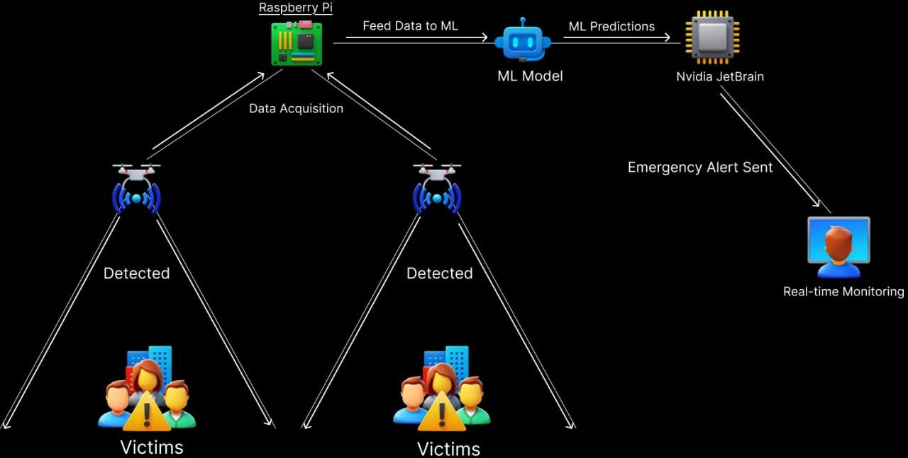
Fig1: System Architecture

1. Input Sensors (Data Acquisition) The UAV is equipped with a multi-sensor payload to facilitate comprehensive data acquisition across varying disaster conditions, including low-visibility and high-obscuration environments:
- High-Resolution ToF Sensor: Facilitates the capture of standard visual spectrum data for spatial mapping.
- Thermal Imaging Camera: Detects critical heat signatures to identify human presence amidst debris or in GPS-denied, obstructed environments.
2. Drone Onboard Processing Hub (Raspberry Pi) Serving as the central data router, this unit manages the ingestion and pre-processing of heterogeneous sensor information.
- Sensor Interface (CSI/USB): Manages the ingestion of raw visual and thermal data streams directly from the hardware payload.
- Data Pre-processing: Standardizes, resizes, and normalizes high-volume video frames to ensure compatibility with AI inference models.
- Communications Manager: Orchestrates internal data routing to the inference engine and facilitates external transmission to the Ground Control Station.
3. AI Inference Engine (NVIDIA Jetson) Functioning as the system’s primary intelligence unit, this module performs real-time analysis and victim classification.
- Inbound Data Handling: Receives normalized video frames from the processing hub for immediate computational analysis.
- Deep Learning Implementation: Executes the YOLOv8 object detection model to achieve high-accuracy detection reliability.
- Feature Extraction and Classification: Analyzes human patterns to distinguish between "Victim" and "Not-Present" classes with minimized false positives.
- Metadata Feedback: Transmits classification results, including spatial bounding boxes and confidence scores, back to the central hub.
4. Ground Control Station (GCS) The GCS integrates sensor fusion results with spatial metadata to enable autonomous operation and rapid emergency response.
- Operator Interface: Human rescuers monitor the mission via a ruggedized terminal to oversee real-time analysis and decision-making.
- Real-time Detection Display: The interface overlays live feeds with bounding boxes and statistical confidence indicators, such as "VICTIM DETECTED (81% Confidence)."
- Spatial Mapping and Alerts: Pinpoints exact coordinates on an integrated map, triggering automated logging to alert search-and-rescue teams.

RESULT & DISCUSSION
The performance of the proposed random forest model was evaluated using precision, recall, and F1-score. The performance of the proposed classification model was evaluated using precision, recall, and F1-score metrics. The model was trained on a large-scale dataset consisting of approximately 20,000 samples, out of which 1,000 samples were reserved for testing, while the remaining data were used for training.
The model achieved an overall accuracy of 81% on the test dataset. For the Not Present class, the model obtained a precision of 0.82, recall of 0.98, and F1-score of 0.89, indicating strong performance in identifying negative instances.
In contrast, the performance on the Victim class is significantly lower, with a precision of 0.27, a recall of 0.04, and an F1-score of 0.07. The extremely low recall suggests that the model fails to correctly identify most of the positive instances. Furthermore, the macro-average F1-score of 0.48 highlights the imbalance in class-wise performance, while the weighted F1-score of 0.75 is influenced by the dominance of the majority class. These results indicate that the model is biased toward the majority class and struggles with effective detection of minority class instances.
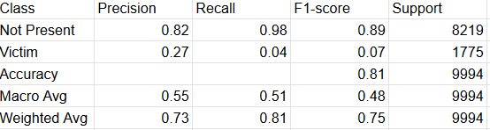
The result snippet is given below :

Real-time victim detection results below:
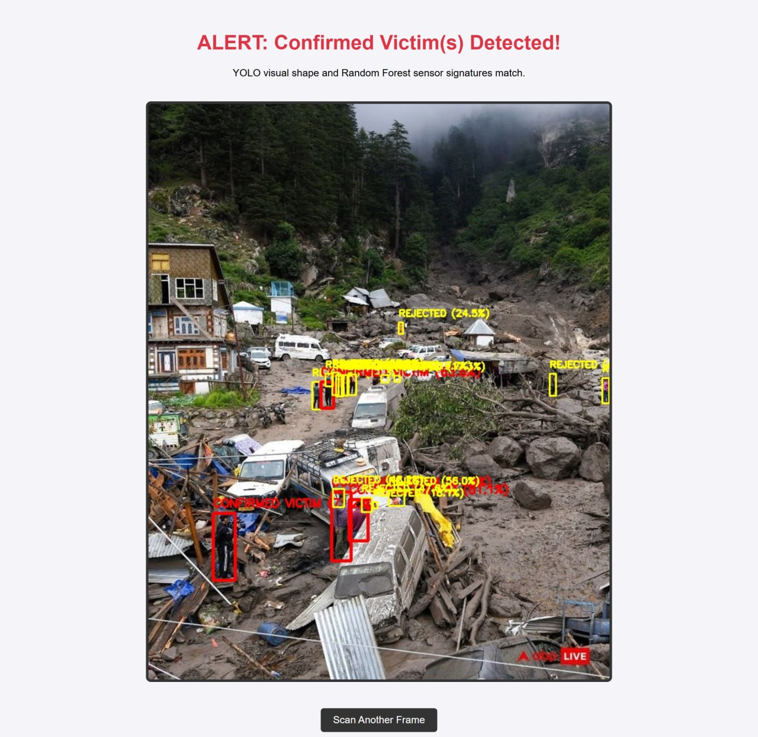

CONCLUSION

In this study, a GPS-independent UAV-based system has been proposed for effective victim detection in disaster-stricken areas. The integration of Time-of-Flight (ToF) and thermal sensors enables the system to operate efficiently in challenging environments where visibility is low and navigation is difficult. By utilizing a sensor fusion algorithm, the system combines data from multiple sources to improve environmental understanding, while the AI-based detection algorithm accurately identifies human presence.

The proposed model enhances search and rescue operations by providing faster detection, reduced human effort, and improved safety for rescue teams. Its ability to function autonomously in GPS-denied environments makes it highly suitable for real-world disaster scenarios. With further advancements and optimization, this system can serve as a reliable and scalable solution for modern disaster management and emergency response applications.

REFERENCES

1. Jocher, G., Chaurasia, A., & Qiu, J. (2023). YOLO by Ultralytics (Version 8.0). Open-source repository.
Redmon, J., et al. (2016). "You Only Look Once: Unified, Real-Time Object Detection." IEEE Conference on Computer Vision and Pattern Recognition (CVPR).
2. Breiman, L. (2001). "Random Forests." Machine Learning, 45(1), 5-32.
3.IEEE Transactions on Robotics: "Multispectral RGB-Thermal Sensor Fusion for Pedestrian Detection in Low-Visibility Conditions."
4. Journal of Field Robotics: "UAV/UGV Deployment in GPS-Denied Environments using 3D Depth Mapping and Time-of-Flight (ToF) Sensors."

